**Experiment 1.2**

**Student Name:   Gaurav Kumar                                UID: 22MCC20177**

**Branch:   CC-DevOps                                                        Section/Group: 1/B**

**Semester:   I                                                               Date of Performance: 02/10/2022**

**Subject Name: ADBMS                     Subject Code: 22CAP-647**

1. **Task to be done:**

You are given three tables: Students, Friends and Packages. Students contains two

columns: ID and Name. Friends contains two columns: ID and Friend_ID (ID of the ONLY best friend). Packages contains two columns: ID and Salary (offered salary in $ thousands per month).

Write a query to output the names of those students whose best friends got offered a higher salary than them. Names must be ordered by the salary amount offered to the best friends. It is guaranteed that no two students got same salary offer.

**Steps for experiment/practical:**

**mysql>** create table students (

-> ID int Primary Key,

-> Name varchar(30) );

**Query OK, 0 rows affected (0.03 sec)**

**mysql>** create table Friends (

-> ID int references students(ID),

-> FriendsID int references students(ID));

**Query OK, 0 rows affected (0.02 sec)**

**mysql>** create table packages (

-> ID int references students(ID),

-> Salary float);

**Query OK, 0 rows affected (0.02 sec)**

**mysql>** insert into students values (1,"Gaurav"),

-> (2,"Raj"),

-> (3,"dev"),

-> (4,"Sam"),

-> (5,"Veer"),

-> (6,"Ajay");

**Query OK, 6 rows affected (0.01 sec)**

**Records: 6 Duplicates: 0 Warnings: 0**

**mysql>** insert into packages values (1,22000),(2,25000),(3,15000),(4,18000),(5,30000),(6,16000);

**Query OK, 6 rows affected (0.01 sec)**

**Records: 6 Duplicates: 0 Warnings: 0**

**mysql>** insert into packages values (1,4),(2,5),(3,6),(4,2),(5,6),(6,1),(3,4);

**Query OK, 6 rows affected (0.01 sec)**

**Records: 6 Duplicates: 0 Warnings: 0**

**Query :**

**mysql>** select distinct(name) from

-> (select s1.id,salary from students s1, friends f1, packages p1 where s1.id=f1.id and friendsid=p1.id) fri,

-> students s, friends f, packages p

-> where s.id=f.id and s.id=p.id and fri.id=s.id and fri.salary>p.salary order by fri.salary desc;

1. **Output (screenshots)**

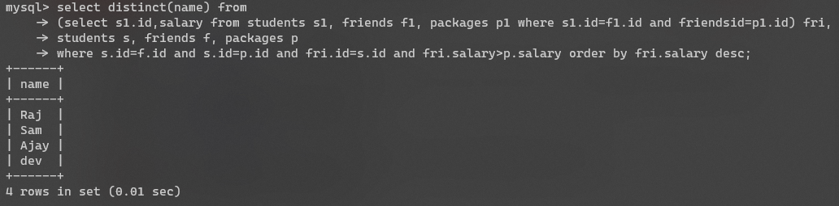

1. **Learning outcomes (What I have learnt):** 
   * 1. **Use of as Keyward to rename column name**
     2. **Sub Querys**
     3. **Order by**

**Evaluation Grid:**

|  |  |  |  |
| --- | --- | --- | --- |
| Sr. No. | Parameters | Marks Obtained | Maximum Marks |
| 1. | Demonstration and Performance  (Quiz) |  | 22 |
| 2. | Worksheet |  | 8 |